AccScience Publishing
doi: 10.36922/JSE026270127

An improved CNN-transformer network for seismic denoising with local-global feature modeling

Supplementary File

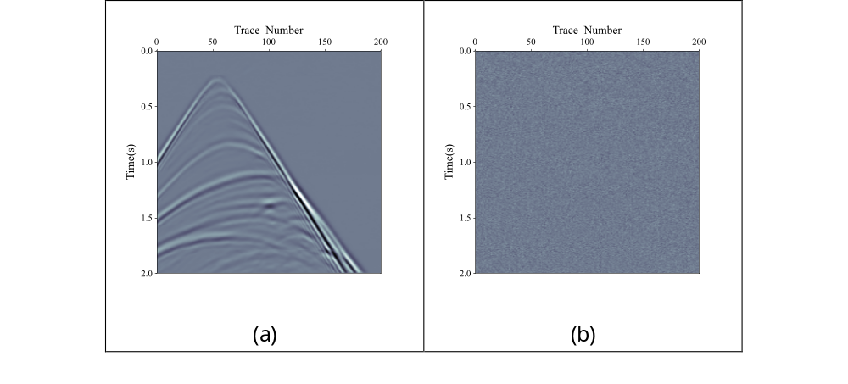Figure S1. Denoising results (a) and corresponding residual maps (b) for the original model with GCB applied only to skip connections. The input noise level is 20 dB.

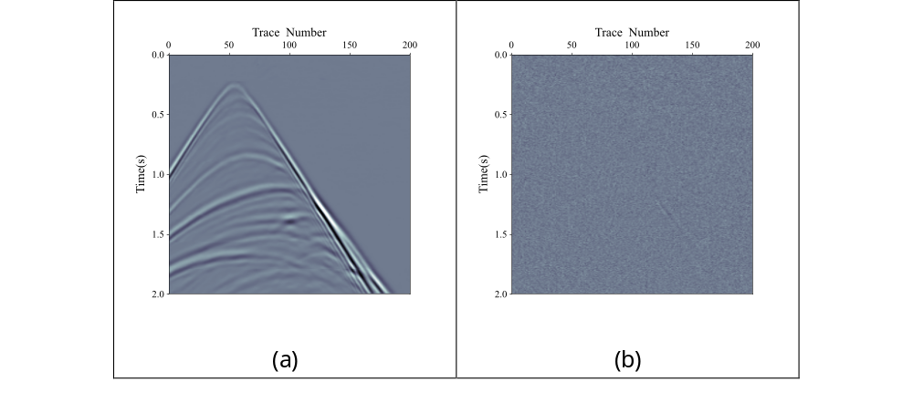
Figure S2. Denoising results (a) and corresponding residual maps (b) for the variant model with an additional GCB module applied at the final concatenation stage (while retaining GCB in skip connections).

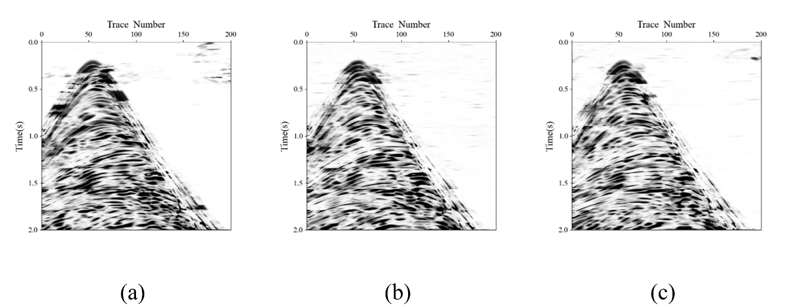Figure S3. Local similarity maps between clean data and denoising results using (a) SSIM loss, (b) hybrid MSE-SSIM loss, and (c) MSE loss.

Table S1. Comparison of the original model and the variant with additional GCB at the final concatenation stage
PSNR | 20 dB
Model | PSNR | SSIM
Original (GCB in skip connections) | 43.26 | 0.951
Variant (+ GCB at concatenation) | 42.80 | 0.948

